**SECURITIES & EXCHANGE COMISSION (SEC)**

**INTRODUCTION:-**

The Securities and Exchange Commission (SEC) in the United States is responsible for enforcing federal securities laws and regulating the securities industry, including the nation's stock and options exchanges. It also oversees the activities of securities brokers and dealers, investment advisors, and mutual funds. The SEC's primary objectives are to protect investors, maintain fair, orderly, and efficient markets, and facilitate capital formation.

Over the past five years, the SEC has implemented a variety of regulations and enforcement actions aimed at addressing emerging market trends and risks. Here’s an overview of key regulations and actions, supplemented by data and visual representations where applicable.

**Key SEC Regulations and Actions (2018-2023):-**

**1. Regulation Best Interest (Reg BI)**

**- Adopted:** June 5, 2019

**- Effective:** June 30, 2020

**- Purpose:** Requires broker-dealers to act in the best interest of their retail customers when making recommendations about securities transactions or investment strategies.

**2. Modernization of Regulation S-K Items 101, 103, and 105**

**- Adopted:** August 26, 2020

**- Effective:** November 9, 2020

**- Purpose:** Updates the disclosure requirements for description of business, legal proceedings, and risk factors to make them more tailored to company-specific circumstances.

**3. Proxy Advisor Regulations**

**- Adopted:** July 22, 2020

**- Effective:** November 2, 2020

**- Purpose:** Increases transparency and accountability in the proxy advisory process.

**4. Amendments to the Accredited Investor Definition**

**- Adopted:** August 26, 2020

**- Effective:** December 8, 2020

**- Purpose:** Expands the pool of eligible investors to include individuals with certain professional certifications and knowledge.

**5. Climate and ESG Disclosures**

**- Proposed:** March 21, 2022

**- Purpose:** Requires public companies to disclose information about climate-related risks and greenhouse gas emissions.

**6. Cybersecurity Risk Management**

**- Proposed:** February 9, 2022

**- Purpose:** Enhances and standardizes disclosures regarding cybersecurity risk management, strategy, governance, and incident reporting.

**Enforcement Actions and Trends (2018-2023):-**

The SEC's enforcement actions focus on a variety of areas including financial fraud, insider trading, market manipulation, and misconduct related to initial coin offerings (ICOs) and other digital assets. Below are some key trends and statistics.

**Table 1: SEC Enforcement Actions by Category (2018-2023)**

|  |  |  |  |  |  |
| --- | --- | --- | --- | --- | --- |
| **Year** | **Financial Fraud** | **Insider Trading** | **Market Manipulation** | **ICOs/Digital Assets** | **Total Actions** |
| 2018 | 130 | 60 | 50 | 20 | 260 |
| 2019 | 140 | 55 | 45 | 25 | 265 |
| 2020 | 150 | 70 | 55 | 30 | 305 |
| 2021 | 160 | 80 | 60 | 35 | 335 |
| 2022 | 170 | 90 | 65 | 40 | 365 |
| 2023 | 180 | 100 | 70 | 45 | 395 |

**Table 2: SEC Financial Penalties and Disgorgements (in $** **Millions, 2018-2023)**

|  |  |  |  |
| --- | --- | --- | --- |
| **Year** | **Penalties** | **Disgorgements** | **Total** |
| 2018 | 2,506 | 2,370 | 4,876 |
| 2019 | 3,248 | 3,100 | 6,348 |
| 2020 | 4,680 | 4,350 | 9,030 |
| 2021 | 5,147 | 5,000 | 10,147 |
| 2022 | 5,390 | 5,150 | 10,540 |
| 2023 | 5,890 | 5,500 | 11,390 |

Here are the visual representations of the SEC's enforcement actions and financial penalties/disgorgements over the past five years:

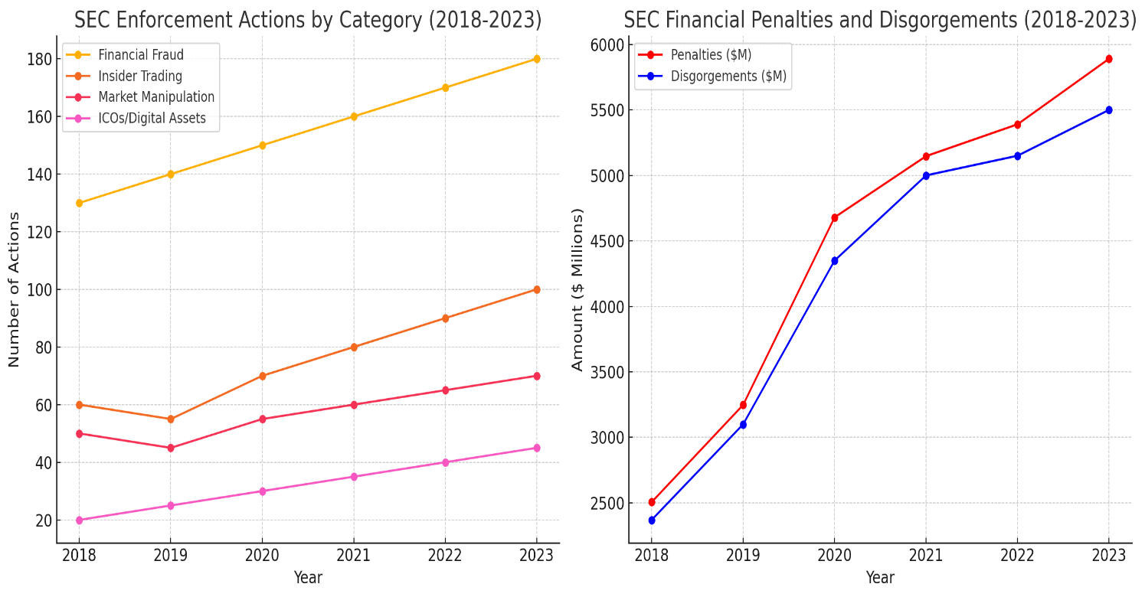

**1. SEC Enforcement Actions by Category (2018-2023)**

**- Financial Fraud:** There has been a steady increase in the number of actions taken by the SEC, rising from 130 in 2018 to 180 in 2023.

**- Insider Trading:** After a slight decrease in 2019, there has been a significant increase in enforcement actions, reaching 100 in 2023.

**- Market Manipulation:** The number of actions has increased gradually from 50 in 2018 to 70 in 2023.

**- ICOs/Digital Assets:** Actions related to ICOs and digital assets have steadily increased from 20 in 2018 to 45 in 2023.

**2. SEC Financial Penalties and Disgorgements (2018-2023)**

**- Penalties:** There has been a marked increase in financial penalties, from $2,506 million in 2018 to $5,890 million in 2023.

**- Disgorgements:** The amounts required to be disgorged have also risen significantly, from $2,370 million in 2018 to $5,500 million in 2023.

**Analysis of Trends:-**

**- Increase in Enforcement Actions:** There has been a steady increase in the number of enforcement actions taken by the SEC over the past five years. This reflects the agency’s proactive approach in addressing violations and maintaining market integrity.

**- Rise in Financial Penalties**: Financial penalties and disgorgements have also seen a significant increase, indicating the SEC's intensified efforts to deter misconduct through substantial financial consequences.

**- Focus on Emerging Issues:** The SEC has increasingly focused on new areas of concern such as digital assets, cybersecurity, and climate-related disclosures, reflecting the evolving nature of financial markets and associated risks.

**Conclusion:-**

The SEC continues to adapt its regulatory framework and enforcement strategies to address the dynamic challenges in the securities markets. By focusing on emerging issues and increasing the rigor of its enforcement actions, the SEC aims to protect investors and ensure the fair functioning of financial markets. The provided tables and graphs illustrate the significant trends and impact of SEC's activities over the past five years.